The success of Instant Experience depend on the better way you design

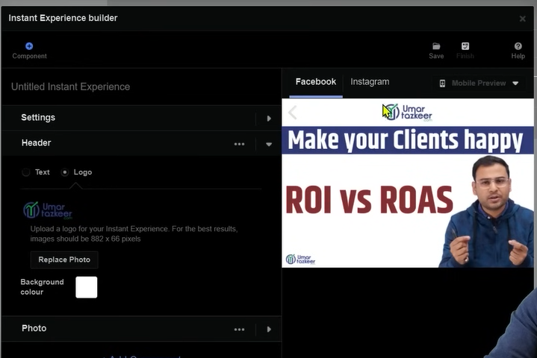

You can add Header and Photo here

We need to understand how to create our page and how our page should look because its success depend on the design

If you do some very basic designing then they will not get good look and feel

It will only work only when you have good design

Now the point is that on the basis of instant metrics do we get some metrices that we need to see and understand

Yes facebook has given us some metrics that we should study

Now we go to our ad manager

And then we go to Campaign tab

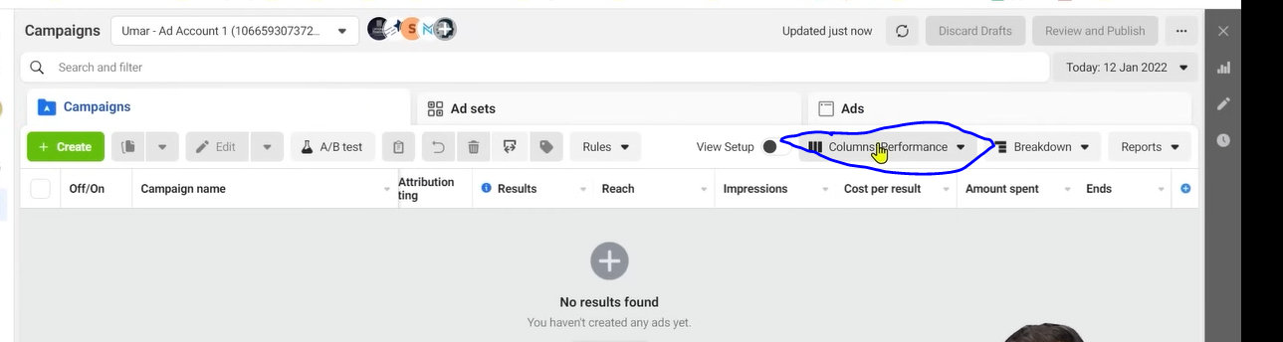

And now we will go to columns(Performance) as marked above (metric filtring)and then a submenu will be opened

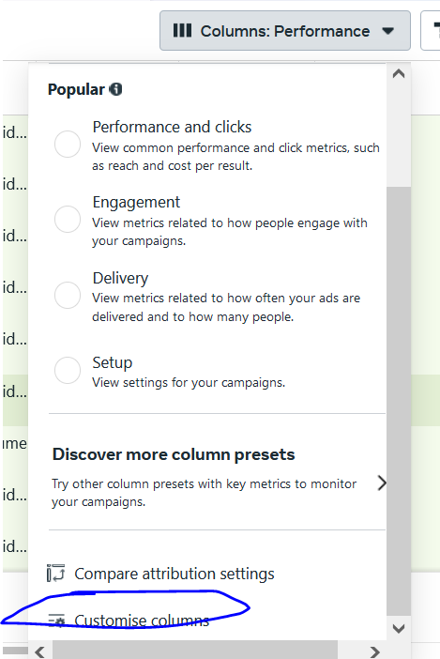

Now click on the Customise columns

Now anew window will open like this

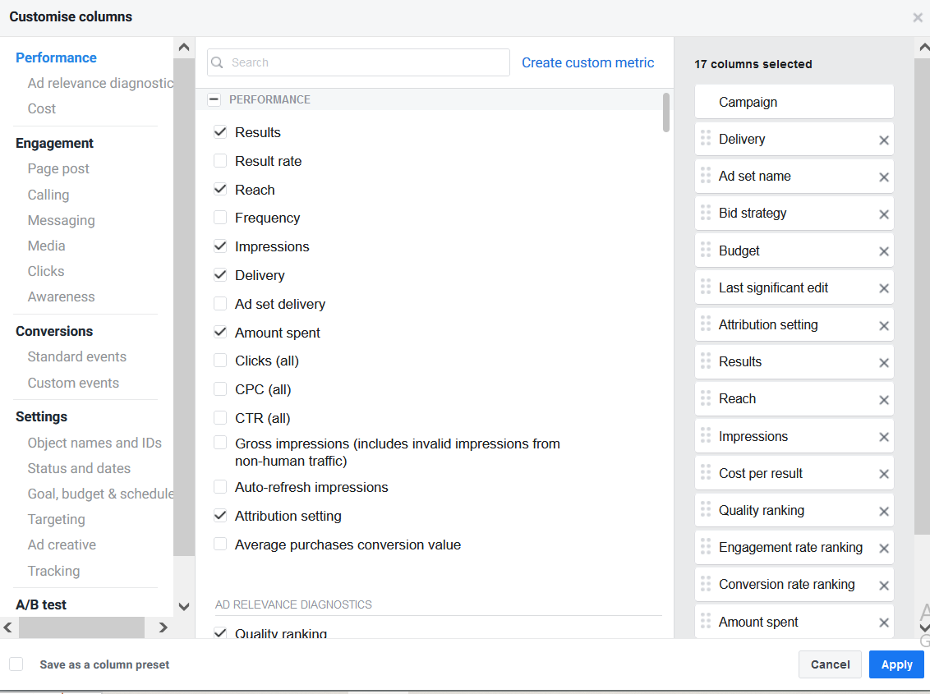

And then search here Instant Experience

It will show the option of metrics related to instant experiences

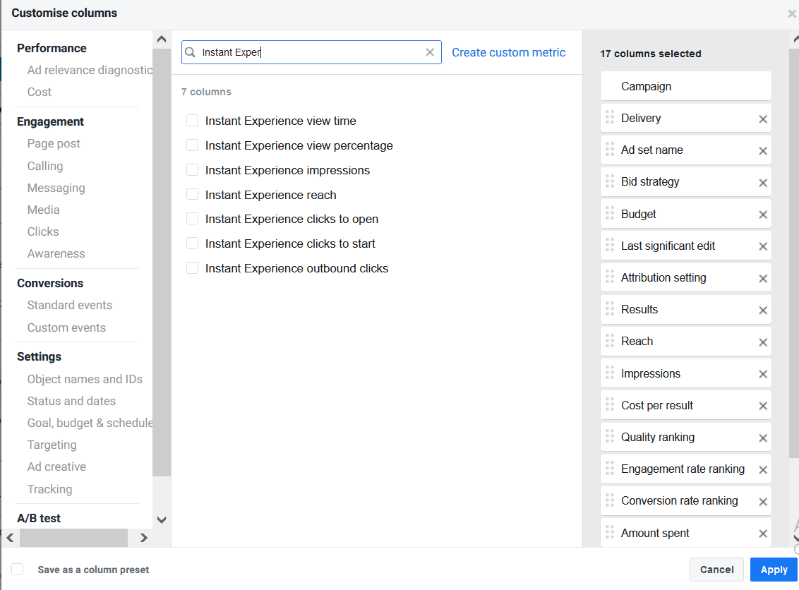

Check the checkox you want to show for your campaign

You can see we have total 7 metrics on the basis of instant experiences

View time means how much the person spend time on instant experiences

What was the view percentafe

How many impression did take place and how many reach were there

How many clicked to open

How many clicked to start.

How many click on the outbound links

As teacher has tell us that in instant experience you create button and attach link to it Now whenever some one will engage with the button then he will reach the link

It can happen that link is related to our website

So any link which is taking you outside is outbound link

**Lesson 57:-**

IN this lesson we will learn about **How to verify domain in Facebook**

When there is a new ad account and we are running ad for a website through it and when you reach your ad account the you get this type of notification or it will tell you some task that says you need to verify some domain

It was not used to happen in past but because of IOS 14 update you see this type of discussion you see this type of pending task that you have to do domain verification

First we will learn what help we get through it and why we need to do it and How to do the verification

There are two reasons why we need it.

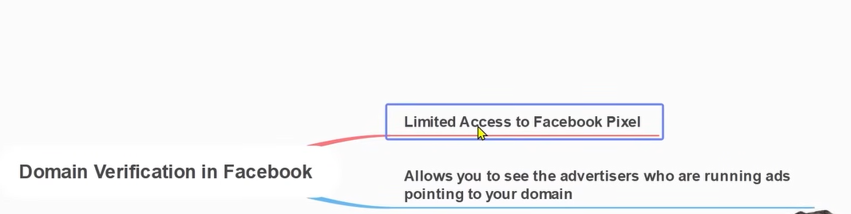

First reason is that the pixel we create and add it on our website and the different event we create for the website we get the information of event from that pixel and this information can correctly reach our pixel for that we need ot define that our ads account and the pixel are connected our domain or we can say for that particular domain we are using that particular account and we are using a particular pixel and running ad through it

What we are saying is that for whatever domain we are running our ad for and whatever pixel we have added on that website so that we can create our events and they are properly attributed means it should not happen that the pixel cannot capture the event properly

So the pixel’s capability or capacity which got reduced because of IOS 14 update we can improve it to certain extent with the help of domain verification.

With this facebook get the signal that by this particular ad account and with this pixel help ad are running for this domain

This is a very important step that you need to do otherwise ut will repeatedly notify you and in many cases when you are running conversion campaign rhere you have to select pixel I want to take this event of pixel as a convergence then you will not be able to select it because you have not verified your domain

Second point is that if there is our website and we have verified that for this website we are running ad by our ad account if there is another person who through another advertising platform pointing to your website then you can see them or the ads who is pointing towards the website So from security point of view it is important

**Phase 74**

(maybe it tells who is running ad in your website in Audience network(who knows))

Now we will see how to verify it. So we need to go to wards out business settings

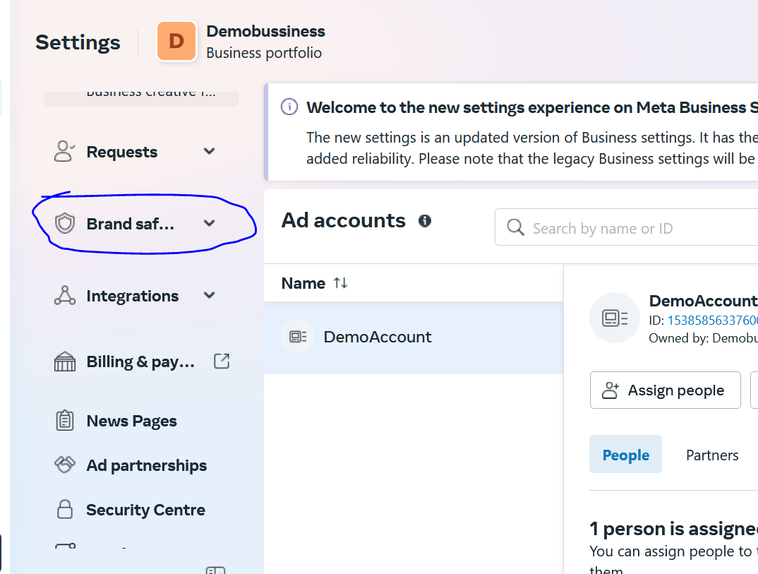

In business setting you will see in sidemenu the menu of Brand Safety

Now whenever you create Business Manager you know by this particular business manager we know the type of domain we are going to use then w verify it here

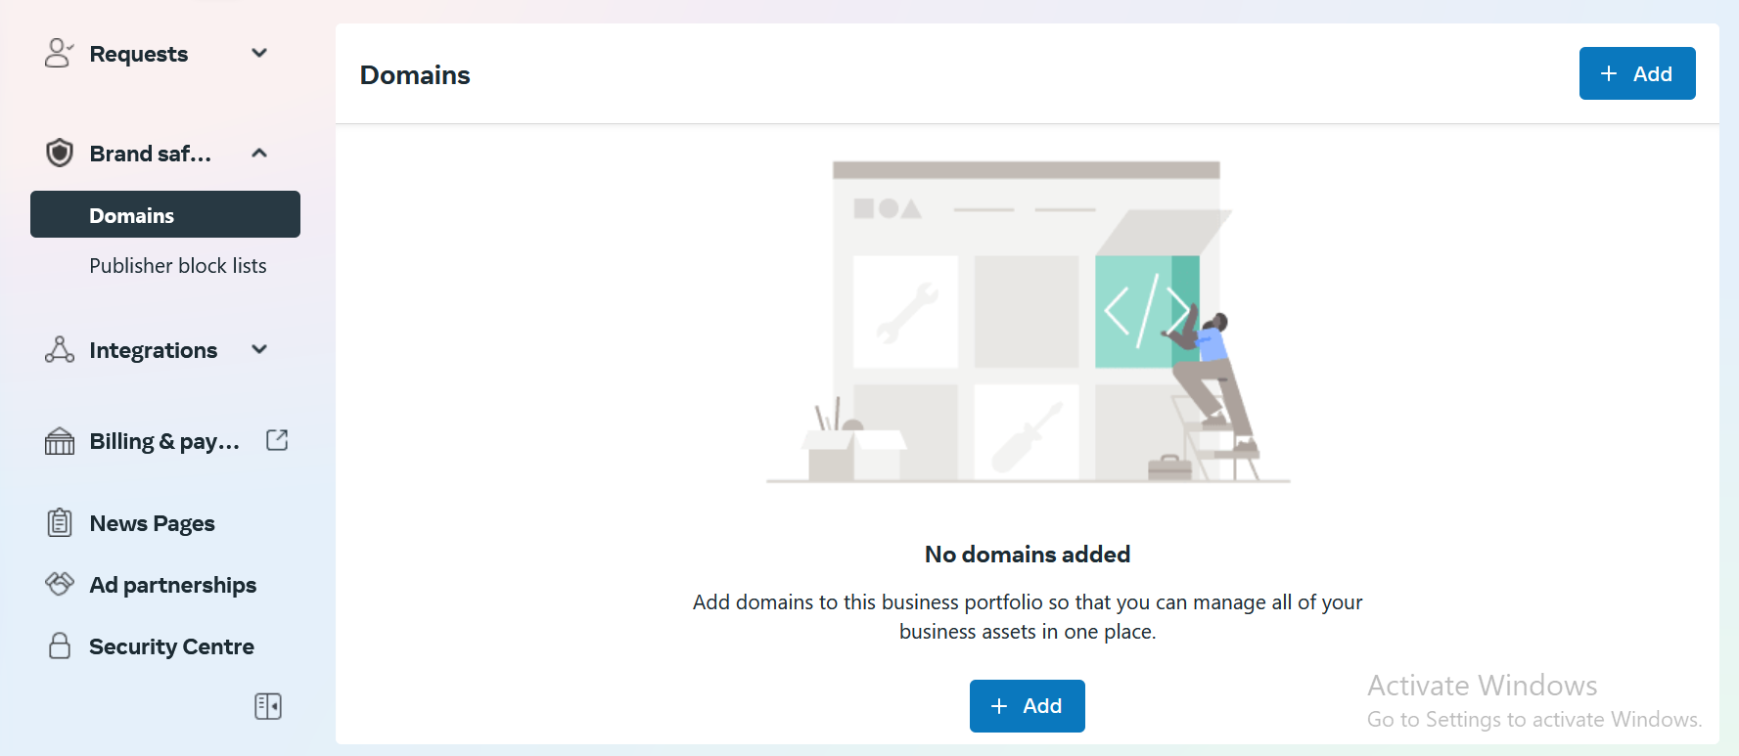

Now we go to Domains as highlighted below click on add button to add your domain and verify it.

Many times when you are in your event manager then there it notify then it notify you to verify your business even if you click there then it will forward you to above screen

And now when you click on add button then you see this window

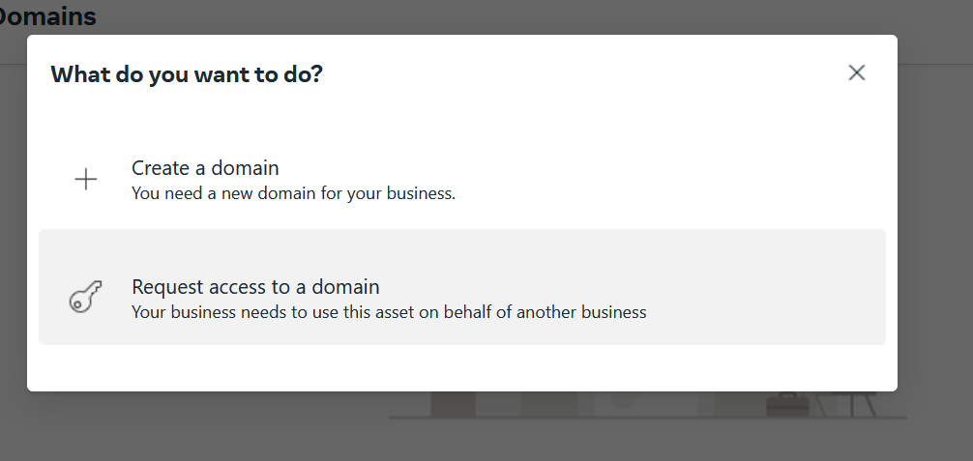

Click on Create a domain

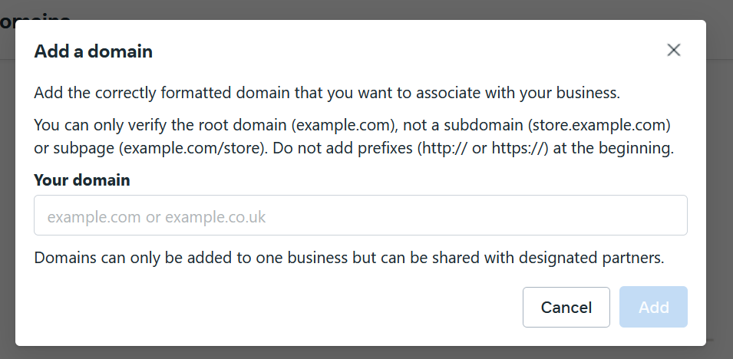

And then you see above screen Type your domain here that you need to verify and then click on Add button

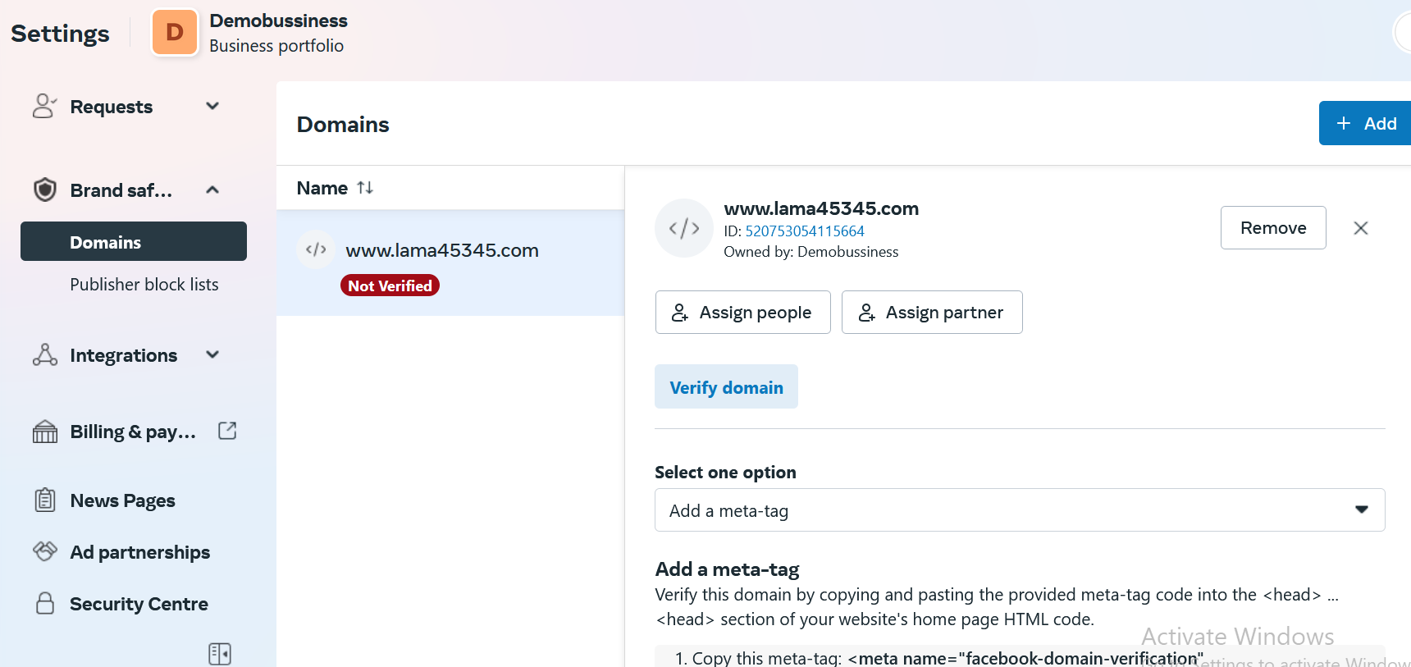

Now you see above interface

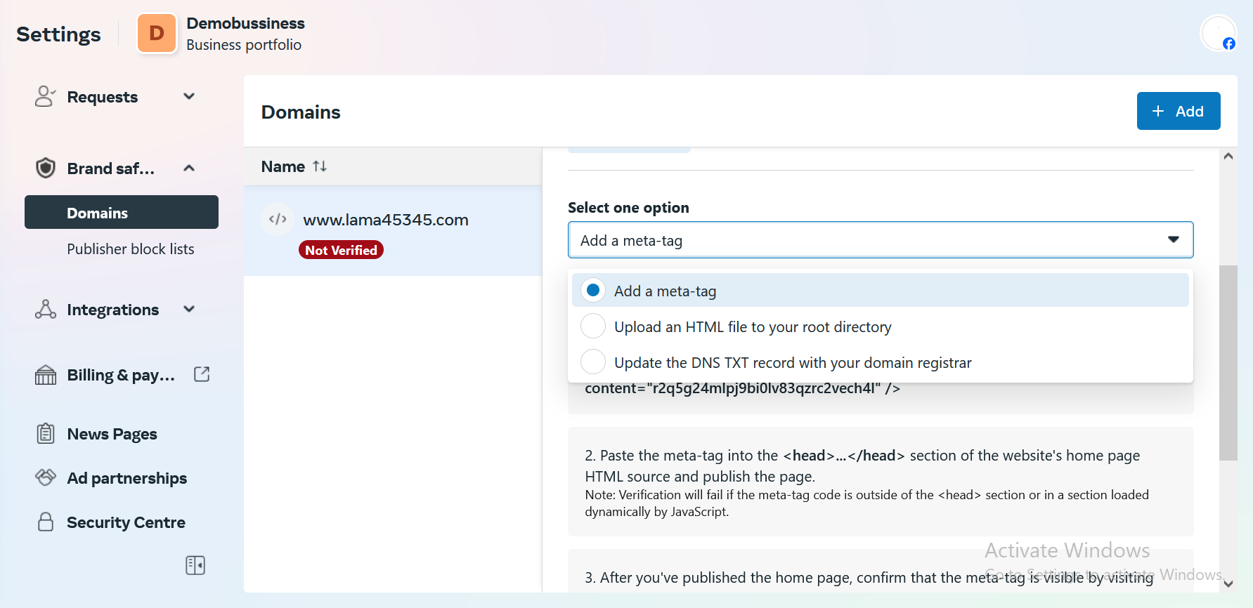now there are different option to verify your domain

First is add a meta tag to your source code

For that you need to have access to your code

Second is upload an HTML file to your root directory in the similar way we upload our sitemap

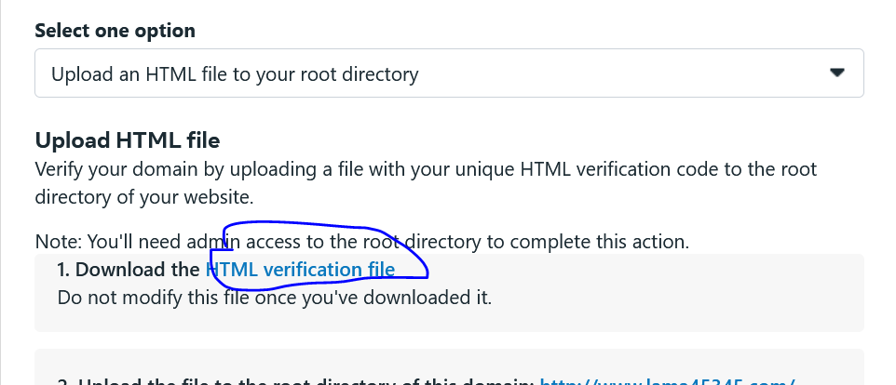

When you choose this then it give you link to download html file then we can upload it to your C panel but it is a very complicated way.

And then third option is update the DNS text record in your register domain

So the simplest way is by adding a meta tag

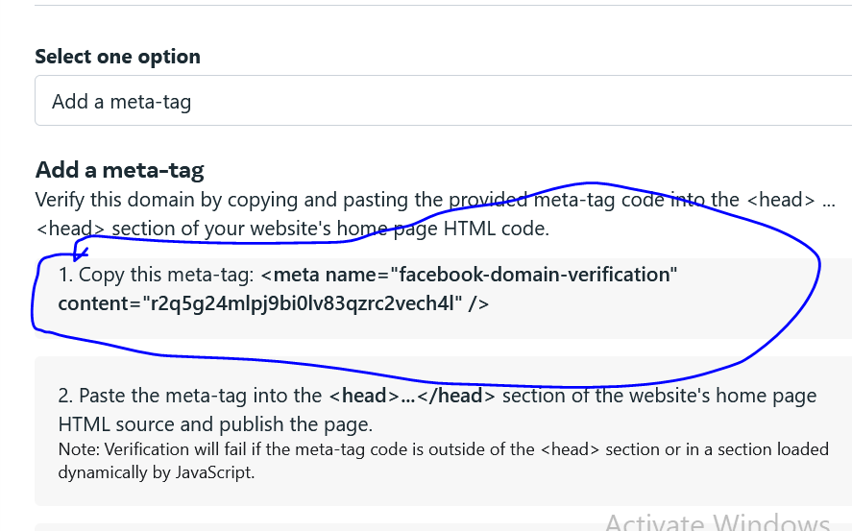

So copy the marked above then paste it in the head section of the code of home page

And now the teacher comes into his backend which is a wordpress

If your website is managed by the developer then give this code to the developer he will add it.So once it is added click on Verify domain button and then you will see in some time your domain will be verified

It is very simple process and it is a must process

So in our wordpress website and then in side menu go to

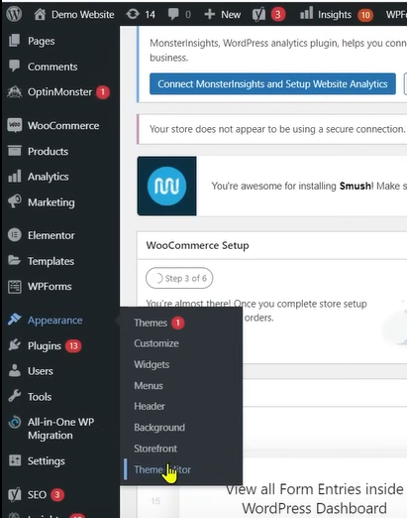

Appearance and then to Theme Editor Now and in that

And then go to Header.php and in head section paste the meta code there.

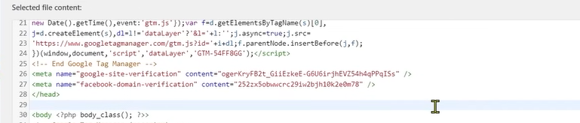

The google site verification is a google search console verification

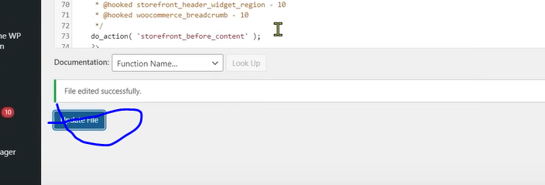

Now click on Update File

Now go back to Business settings and now click on Verify Domain as marked below.

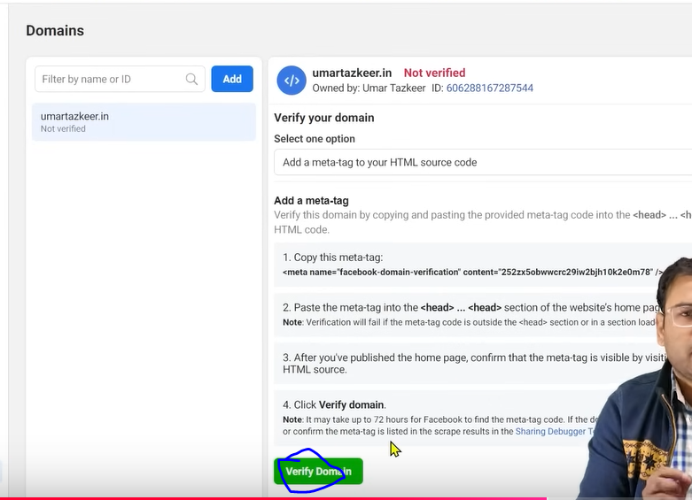

Sometimes it take time to verify it.

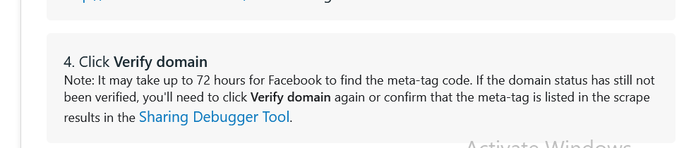

It is clearly mentioned that it will take upto 72 hours

We may need to debug it sometime but you will neot need it because it is avery simple code

Lesson 58:-  
In this lesson we will learn about How to **Create Image Creatives in Facebook Ads**.

You cannot talk about Facebook ad without testing

When we run our campaign in our facebook then one thing comes in our mind automatically that we need to text many things whether it is audience or ad creatives

When we talk about testing of ad creative then the most creative and fundamental thing is that we can test different creative

And then you will see that in ad set there are some images that get push by facebook algorithm and give better performance (more impression ) and some image does not perform well

So whatever we do the testing for we get the result

There are some images which are liked by facebook algorithm and it boost it and on the basis of that we get good result But why and how this thing happens

We are saying on what parameter or on what basis that this image is better for audience and this particular will be pushed by facebook

There are any factors determine it that which image is better but from them if we talk about important facetor that is actually text rule How much text should be in our image

Facebook don’t like it that you use lots of text in your image

If there is lots of text in your image then facebook will not give it too much priority and will not promote it in better way and will not make it reach to the people and for that facebook made 20 percent rule which has been abolished where the condition was that your image should contain atleast 20 percent text and 80 percent graphics. If you did not meet it then in some cases it does not get approved and if it get dissaproved then there performance is low and reach will be reduced after some times facebook removed third rule means there is no some condition that should not keep more than 20 percent text but still it is seen while experimenting that when you use more than 20 percent text then you don’t get good reach mean even in todays time you have to make sure that your image should not contain more text facebook don’t like it even no system likes it you use more text in images because any system or bot gets problem in understanding what is wriiten in the image

And advertiser very smartly to improve their CTR or can write any topic due to which viewer click on their ad. So in small number of impression they get more click due to which they get good CTR

Any ad platform system does not like this that you write text in creative due to this reason facebook has given you field like primary text, Headlines ,description

Suppose if your running 5 ad with different images and in these 5 images 2 ads are performing better now if you by applying permutation and combination you try to study about it then you will understand that determining factor is that in our image if there is less text then the probability that the image will run increases mean reach of image increases and they get lower CPM (who knows)

Now the 20 percent rule has gone

**Phase 75**

Now there is metrics

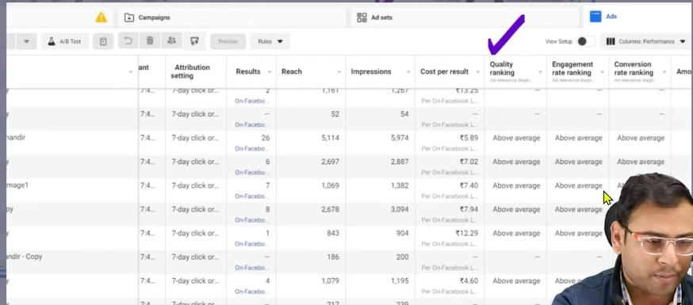

You can see the quality ranking as checked above

Quality ranking determine the quality of your image

If you are using more text in image then the quality will be average or below average

Otherwise the ranking will be above average. If you are getting below average or average rating then there are high chances that your image performance will be good

You can see the teacher has kept the Quality metrics , Engagement rate ranking and Conversion rate Metric etc above average.

Now there is another way of measuring how our ad are going to perform

If you write text more then 20 percent then the CPM increases

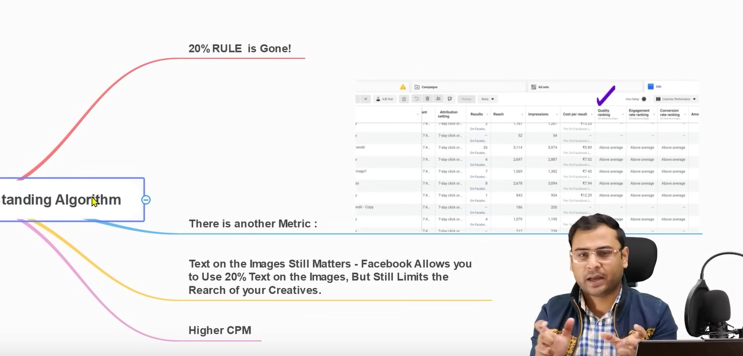

So make sure text should not be more

So(who knows)Don’t try to manipulation

Whatever the text you want to write write it in primary text, Headline etc.

And make sure the images are clean so that your ad can get algorithmic push.

There are many small small things which we ignore and focus on Audience , Hacks, and data collected in pixel and we need to keep thing sure that How our creatives should be like that our facebook ad algorithm like them. We should understand this points if we want to become a better facebook marketer.

**Lesson 59:-**

In this lesson we will learn about **how to change history Feature in Facebook ads**

Whenever we work in our ads account then such situation can happen that we need to give our account to different people

In agencies setting it is very common practice

Now people have access now they can bring changes in them also but many times it happens that we want to understand who bring changes in our system it may happen that the person is in your team member. And these changes bring negative impact in your ads account and now you don’t even know who bring those changes.

So to understand these things and such situation does not occur to safeguard us from it. Facebook has given us change history option similarly the option we have in google ads.

Whoever has access to your ads account bring some changes in it or any change you will come to know about it that in that a particular campaign what particular person bring what changes and when that page happened

Thi is a vey important feature

And people who work in agencies for them it is very useful

Suppose we come to our ads account

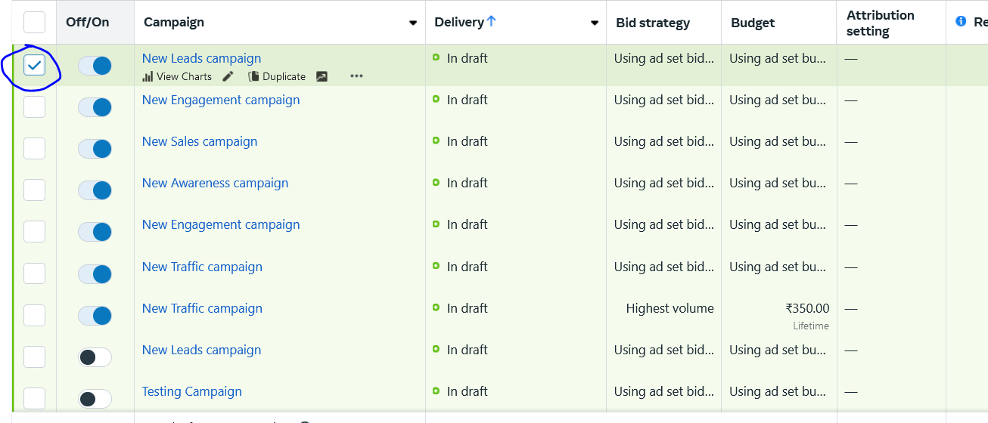Now suppose We want to see the changes in the marked campaign above then we check the checkbox

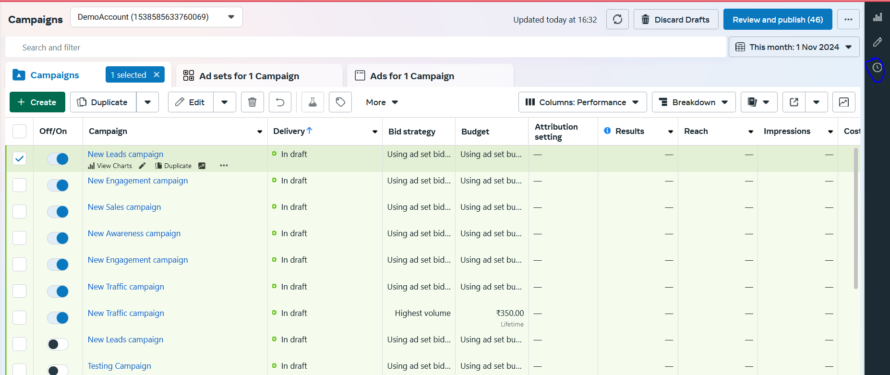

Now you can see in right side menu you will see a click simple as marked above this is actually (see history)

Now we click on it .It will show the history of checked campaign.

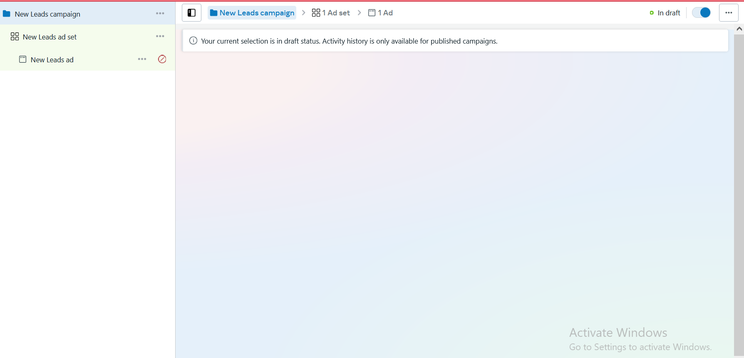

It is not showing something because our campaign is not published so we will see from Teacher Perspective

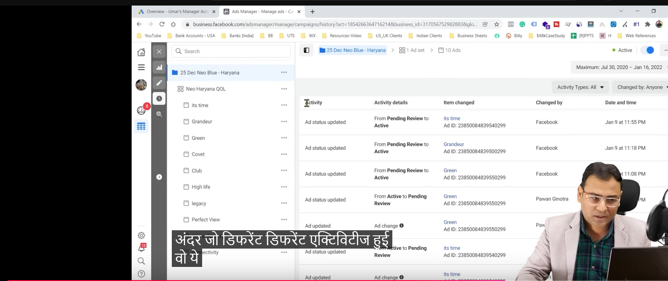

Now you can see in this particular campaign the different different activities happened

And it also show activity detail like from pending review to active “This is a change”

And in changed by it is written facebook because it is done by facebook to make the campaign from review to live

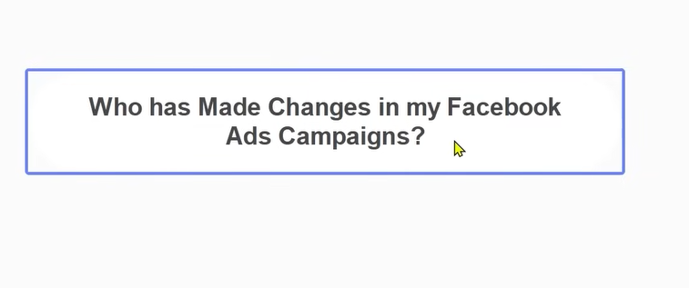

And from change in “Active to Pending“ in change by field it is changed by <username>

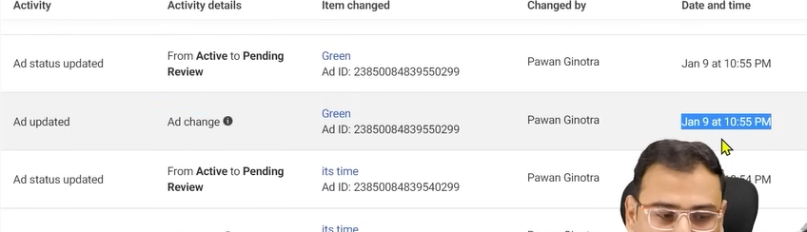

It also tell date and time when did the change happen

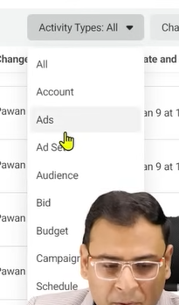

You can also filter them by click in Activity Types:All button a submenu you can click on any option to filter it

You can filter according to campanbaing based changes(who knows)

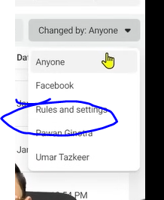

And in Changed by you can filter according to the change done by the people or entity

Many times it happens that rules bring changes in our ad account or campaign means the user is not bringing changes manually changes are being done by the rules.

So for that you can click on the Rules and Regulation button

It is very useful especially if you are working with a team

**Lesson 60:-**

In this lesson we will learn about **Scaling of Facebook Ads Campaign**

Now we will see different different method through which we can scale our campaign.

We see scaling of facebook ads

What is the meaning of scaling od Campaign or facebook ads

so we will see the methods of scaling later

we will see the meaning of scaling of campign/business/ads

What does these mean and what we need to understand from it.

This is important conceptwise

So suppose we are running our facebook campaign Lets say it isa lead generation campaign that we run on facebook and the amount we keep in it is 1000 rupees per day. And the lead we get is on an average 100 leads and we have run compaign in a good way.

So then cost per lead will be rupees 10.

Now we see the quality of leads is good and when we talk with lead then we get better usiness after contacting with them.

Now we want that my lead generation should be scaled.. What is the meaning of scale

Now the 100 leads we are getting now we want now that we get 500 leads. Because leads quality is good and CPL is rupees 10 so we can afford it

SO on the basis of ruppes 10 CPL we want 00 leads now this is scaling when you want to expand your business

If we talk about any normal business and when a term is added that is scaling of business so it simple mean you were dealing with 10 clients previously now you want that you get 50 client   
Buut what is its meaning in the context of Faceboook ads means scaling in Campaign or scaling of ads



Scaling means increasing your Campaigns budget while maintaining a positive return.

Simply it means that we want our campaign should give 500 leads and our CPL should be rupees 10 or below it and should not be more than 10

If we are getting 500 leads but our CPL is 15 then it will not be considered scaling.or what type of better scaling is this

So we just want that our result get increased and.

**Phase 76**

the cost per result should be maintained or it may become better

Why we are giving it so much importance and why we are talking about different methods of doing things.



We have above scenario but we want to bring 500 leads so we need to 5 x our budget that is 500 rupees and our CPL would be maintained we tend to think like that but such things does not happen

So scaling is not that easy. When you see in real time

You will may get 400 leads in 5000 rupees budget now our CPL will be 12.5 rupees which will not be good means we have not done the scaling in a god way.

Just multiplying the budget is not scaling I would not get the result like this.

So what are the correct methods to do it

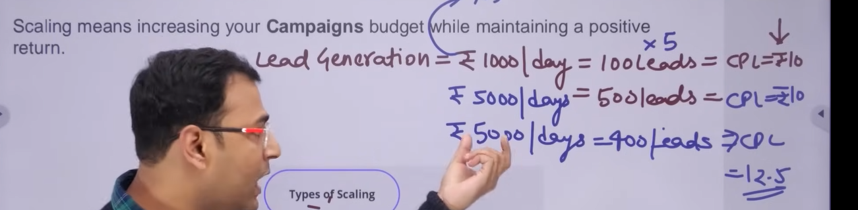

Basically there are two types of scaling

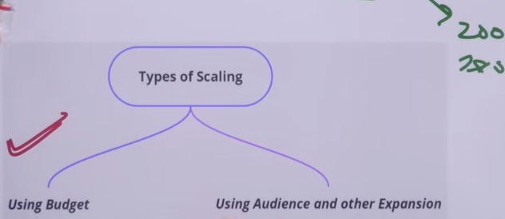

1. Using Budget
2. Using Audience and other expansion.

In using budget we increase the budget but there are strategies and logics to increase our budget SO it is not like that just we increase the budget 5 times then the outcome will also increased 5 times.

We need to increase the budget but there are strategies to increase the budget

How we will do it we will talk about it.

In “audience and other expansion” we expand the Audience and location to do scaling

The Using budget method is also called vertical scaling

The using Audience and other expansion is also called Horizontal Scaling.

How to play with budget and how to do our budget based scaling we will see it here

First you need to check the frequency of your ad.

If your ad frequency is less than 2 then your ad is not viewed by the same person means there is not condition of ad fatigue and if there is no condition of ad fatigue means we can increase the budget. We get the green light to go forward then.

First we need to decide do we need to do the scaling or not and then we decide how to do it. Means do you want to go to vertical scaling or need to do Horizontal Scaling.

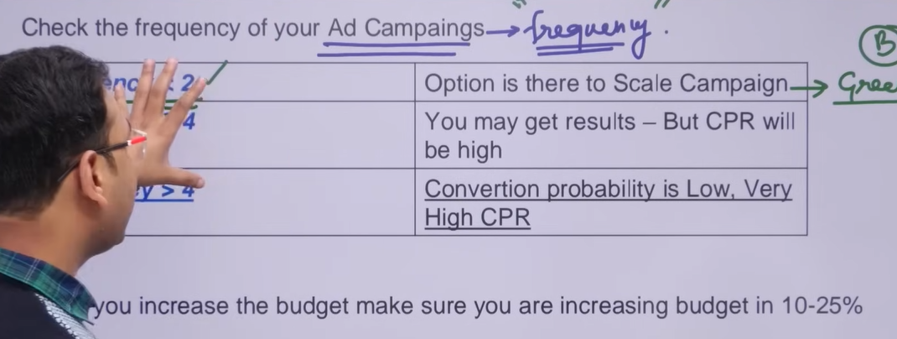

Here the criteria you see above is basically do you need to go towards vertical scaling or not

So if my vertical scaling is very less than 2 means there is scope of increasing our scope of scaling the campaign Now our ad is not like this that it is being shown to the same person. Here we can increase the budget and how to do it we will talk about it later.

Now we talk about if our frequency is between 2 and 4 so there now a slight condition of ad fatigue. So now if we increase our budget then people will see it many times

If that person has to done the convergence in the first case or they have not bring any result.

The person will see the ad many times but will he do the convergence that is no and because of impression the budget will be exhausted.

So in case of this frequency of 2 to 4. If we increase our budget then we may get result but our CPR will be high

So there are moderate chances that you get the performance or it can happen that you don’t get the performance.

So there is a green signal but an immediate green signal you have to study her that you need to increase the budget here or not.

Now if the frequency is more than 4 then the probability of conversion get reduced very much The person have already seen the ad 6 times if he would have wanted to converge then he would have converged the first he see the ad.

So there will be low convergence and if there will be convergence then it will happen after many convergence that the cost will be increased and convergence happens very less.

So in such cases our cost per result will be less

SO if frequency is less than 2 then increase the budget

You may argue this is the same thing we had done previously

You can do the vertical but the way to use it

If we increase the budget instantly then our campaign which already learned something

In my campaign there is some audience, budget, some placement we had done. On the basis of that it has optimized itself due to which it is giving us result now what we had done we have instantly increased the budget ten its whole learning will get disturbed (who knows) because with time the campaign learns something So by learning it establise itself and around this budget it is bringing performance to us.

Now you have instantly increased the budget when you increase the budget instantly then many settings which were previously there they will get disturbed When those setting gets disturbed so your CPR will be disturbed

So first you need to whether you want to go to vertical scaling or Horizontal scaling

Means if your frequency has become high and still you are increasing your budget then you are creating problem for yourself

Now we will see how to increase our budget

If you want to increase the budget then make sure you are increasing the result 10 to 25 percent range.

Mean it is not like that you increase the budget 2x or 3x or

**Phase 77**

whenever you feel that you are increasing the budget too much and campaign learning may get disturbed So what you need to do is that suppose if your 1000 rupees budget then increae it gradually measn we increase the budget to 1350 rupees so you have to increase the budget slowly slowly in 10 to 25 percent range

You may see that CPR may get disturbed but it convert itself later if your budget changes are not very big.

The CPR will get normalized eventually (may be take upto 24 hours)

Increase It slowly and then reach your target slowly

If your budget is 2000 then you can increase it to 2800 and when you campaign get stabilized in 2800 rupees then we increase it to 3600

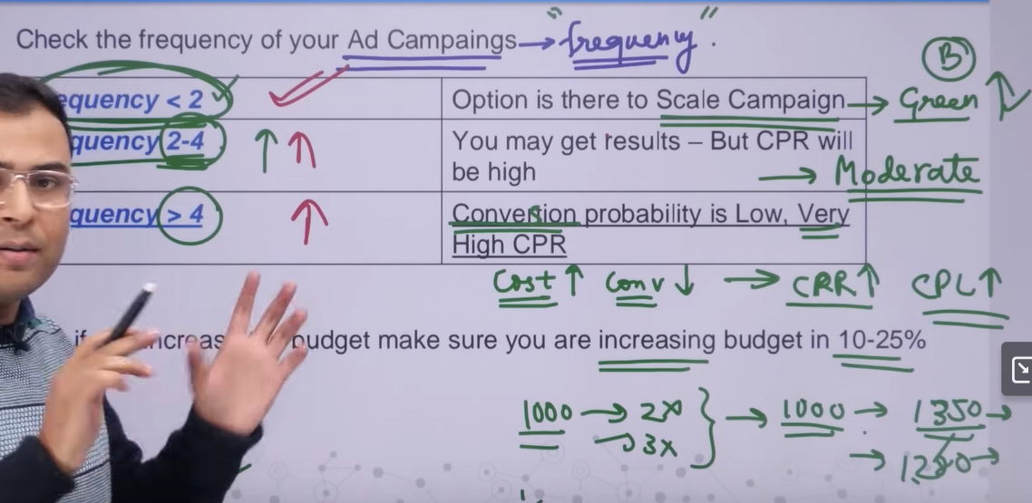

If your situation is like frequency 2-4 and frequency>4 then can we do scaling yes we can do it but then the method which is used will be horizontal scaling

Whether we do audience expansion or do location expand(maybe notation)

The fatigue situation arises in these two scenerios even if you increase the budget then tose people will see those things repeatedly How we can save it from us We can us from it by adding new members by adding new members we mean adding new audience or how we can add it

We cannot add it by going to new location means first I was targeting in Delhi now we are also targeting in Mumbai So we targeting people of same characteristics in these two cities

So what happens is that audience size increases and when the size increases then your frequency will reach normalization situation.

What actually we are saying is.

So basically we are saying is that in scaling frequency metrics play a great role.

Now we are seeing the option of playing with audience

If we talk about expansion there are some ways

First is by assigning different locations and you can also increase by using Lookalike audience

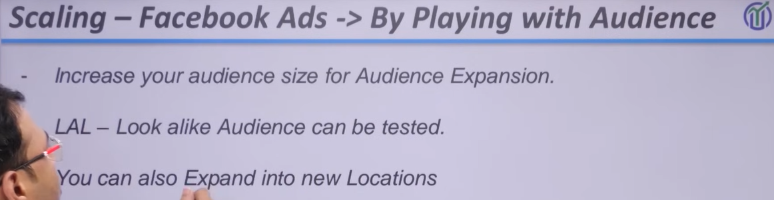

But many people get problems in budget expansion which we studied earlier

Make sure your campaign is in which situation if your campaign is eligible that you need to do budget expansion then do it and if you see there is a problem of frequency arising in the campaign or frequency is increasing if it is getting increased then you need to expand your audience By doing it maybe your frequency get normalized then again you can do budget expansion but increase it the way as told by the teacher earlier

**Lesson 61:-**

In this lesson we will learn about **How to create store Traffic Ads**

As we have many option in creating different facebook ads some of them is Store Traffic ads or campaign

In new UI there is no Store traffic so we will see this lesson from Teachers perspective

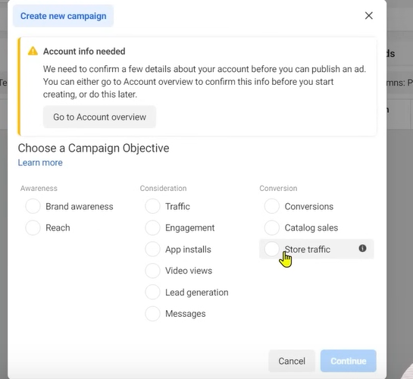

In campaign creation window there is an option of Store Traffic

First we will try to understand why there is store traffic and for what type of business and how our ad is shown by Store Traffic

What is required to set it up it and how to set up it

It is different from another campaign type

If we talk about its purpose then

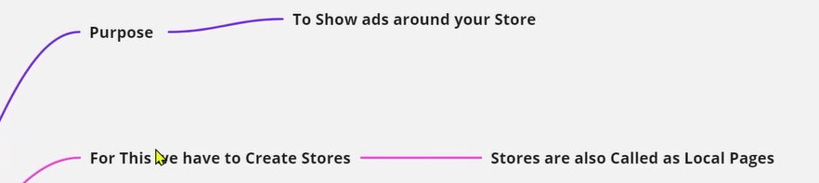

It Is optimized for local business

To promote Local business Store traffic ad is used

Suppose if you have a shop and through shop you do such type of business that nature of business is that you are providing product or service through shop It is not like that person can take your service from his home like Digital products

But if talk about business that we need to come to that shop or to the physical location and the shop potential customer live around it.

Means we are assuming that business local and it operate in a physical location and to interact with this business people have to go there and its potential customer liver around it. So for that type of business we run store traffic campaign

So the purpose is that wherever our shop is (physical address) around that area in a certain radius we will run our ad

You will say that the same work we can do in other normal campaign.

We can do this by traffic campaign also by location targeting means radius targeting what is so special in Store Traffic ads.

Guys we have taken a scenario we will understand it then you will understand the potential and how many things we can do by tore traffic

We are talking a scenario of dry cleaning services and they offer their services across India

People go to their shop and give their clothes and get them dry cleaned It will not happen that the dry cleaning machine will come their house means nature of business is like that the potential customer has to come on their own to the shop location if he want services.

We assume that their branches is all over India.

So different stores of business can present in different location

Now every shop has some attributes

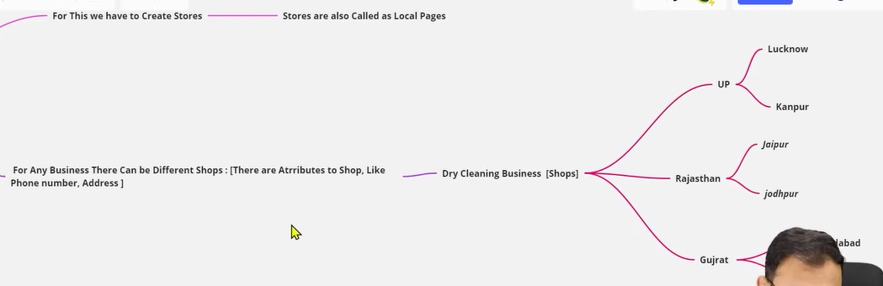

Now you can see above that this dry cleaning business is in UP, Rajasthan, Gujarat and in UP there are two cities that is Kanpur, Lucknow, and in Rajathan there are two cities Jodhpur and Jaipur and In Ahemadabd ther are two cities that Is Ahemdabad, Surat

Now we want that when we run ads in Rajasthan and as it has two stores one in Jodhpur and another in Jaipur.

**Phase 78**

In Jaipur location there must be some address or phone number related to it

So we want that in Jaipur In our ad whoever see his ad and when they click on thie ad they will get that shop phone number and that store address and when they click on get direction the Jaipur related destination(address) should be shown to them. If we together through one campaign run ad in whole state which means that is there are five stores In Rajasthan then when these stores ad will run in their respected radius

If we want we run store traffic ad for all the stores in rajasthan so lets say there are 10 stores in rajasthan then whatever number of ads will be shown when the user will interact on those ads then whatever address or phone number shown there will be related to that store whose ad is shown means store has individual identity

Every store has different address or Phone number

I say that my ad should run on all the stores in Rajasthan or we say our ad should run for all the stores in UP If even there are 50 stores in UP then our ad will run in the stores specific specified radius

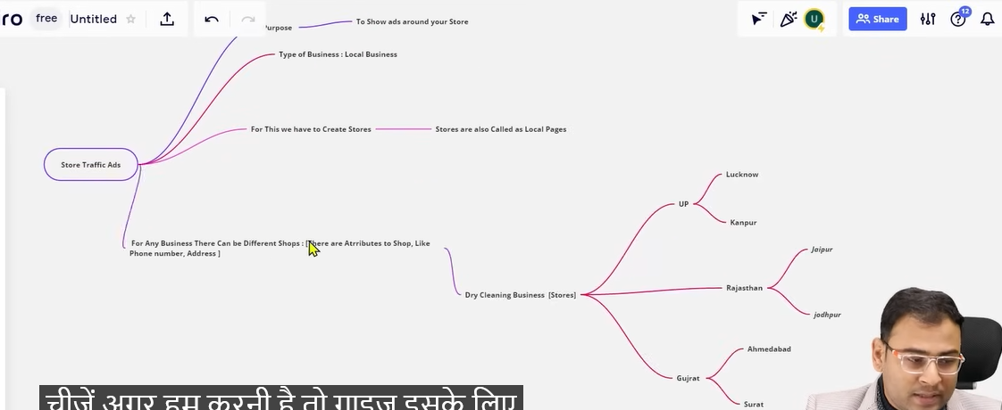

To do all these things we need store traffic ads means a new terminologies which is actually store so first we need to build store first we need to build Lucknow store with store information in terms of address and Phone number

So requiremtn for store traffic ad is to first build your store first

WE will see how to build our store now and then how in terms of these store we can run our ads

Another Terminology is used there that is store set. It means If in a particular state there are 4 stores in different cities. If talk about on state level then this is our store set and in this store set there are four stores and now we want that for this storeset a store traffic ad will be run. So all our stores inside this storeset will run their ad in thir fixed radius specified by you.

Now try to understand its benefit that our five stores are in different different cities If I show them only one address then it will create a problem I will not make them come to only single address

We want that if Delhi person is seeing this then closest store ad will be show to him If mumbai then mumbai closest store we can set to all statewise measn we are running ad for a particular stores in a state) If there is such requirement hen you should run store traffic ads

Phone number and address will be storewise. So for that when It will start

Until now we represent out businesses by our page We have one facebook page we keep our address and Phone number there since it is one business so if someone want to take information of that business he can take it from here.

But here we are not talking about one address not more than one addresses but also more stores In such situations we need to create more stores

So our store traffic work start from here what are the different location of the shops of a business and then comes store set and then then we will run our ad.

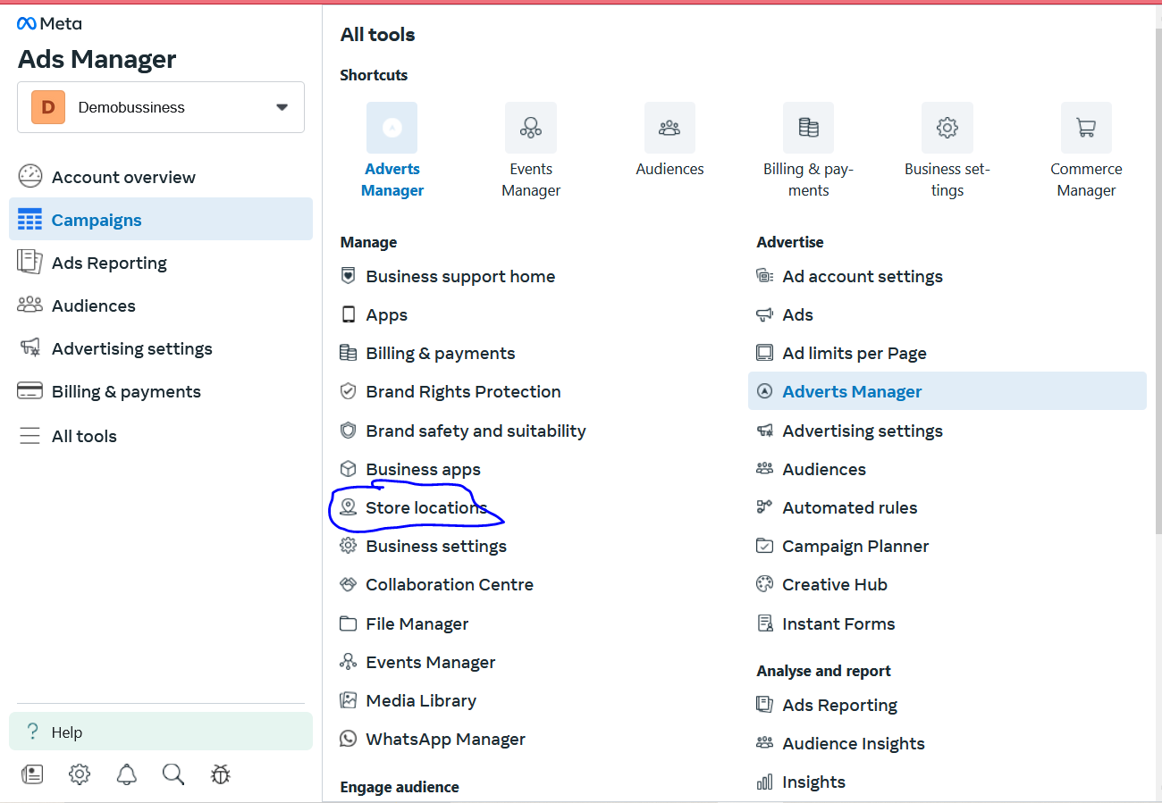

Now ion our side menu go to All tools and then to Store Location

And then a new page opens

Since my profile don’t have any image so I cannot access it so we will see from Teachers perspective

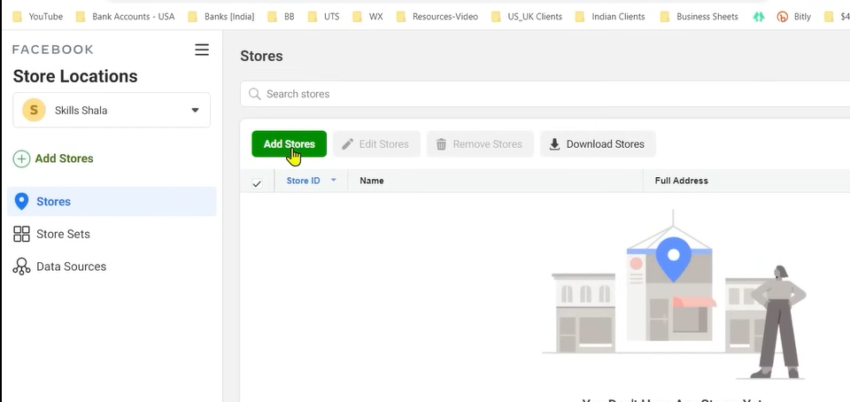

Herer you get options to add stores . Now when we add stores then on the basis of these stores we can make our store set

SO we click on Add Stores

And then a new small window will be opened

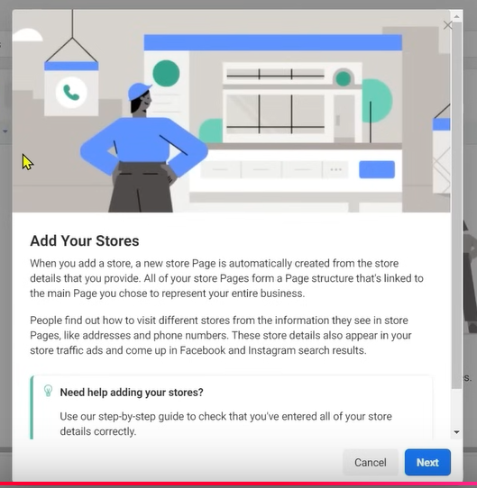

Click on next

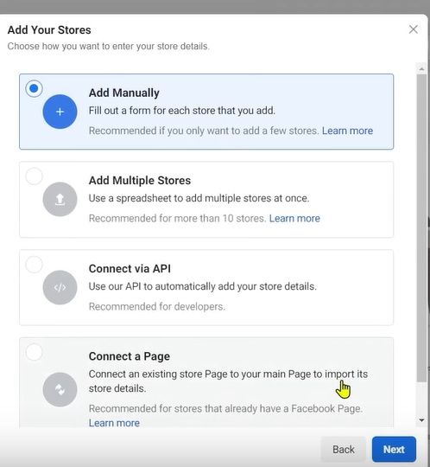

CLikc on add manually to manually add our store

You can choose Add multiple stores to add multiple stores with the help of spreadsheet

Now click on next button

And then this small window will be opened

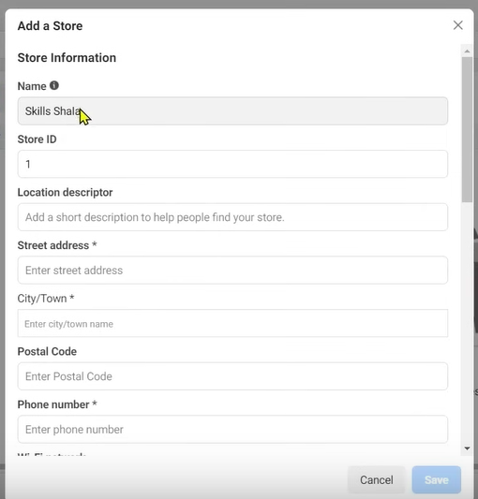

Your store name will be filled by name of profile (may be business name mentioned there who knows)

In store id tell the store id you want to set

In location descriptor tell how people will find your store

Fill all the details of the releted to your addredd

In wifi network name you can tell the the location wifi (who knows)

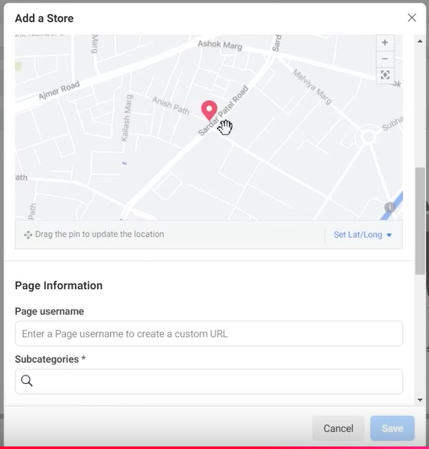

If you sure about your address then you can set it with the help of map as shown above

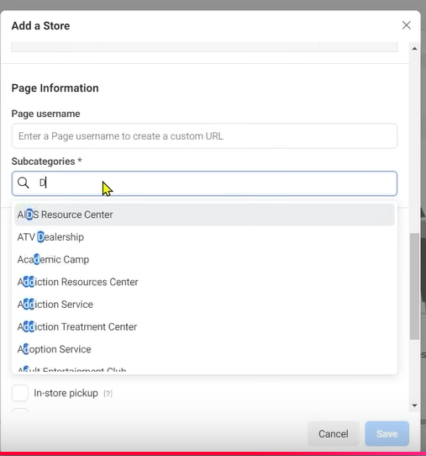

On subcategories you tell for what type of business our store is for you can choose from the list suggested while typing about sub categories of business

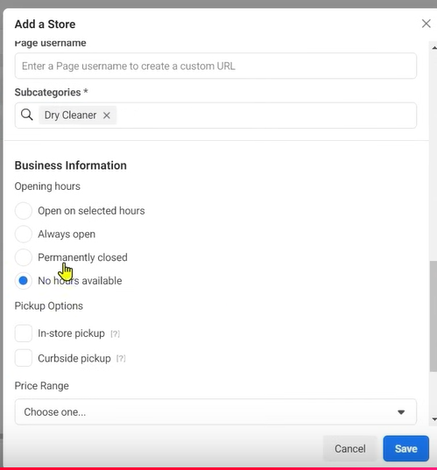

In Business Information Opening hours when your store will be opened

We choose Always open

You can also tell about pickup option

You can also tell Price Range

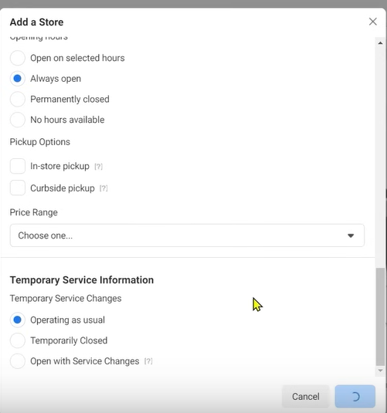

In Temporary Service Information choose Operating as usual . Now click on Save button

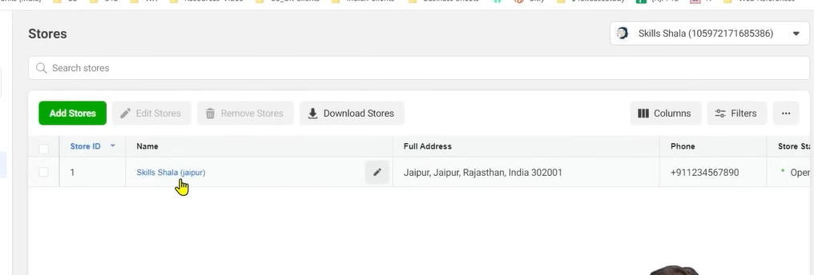

The store will be listed you can see above

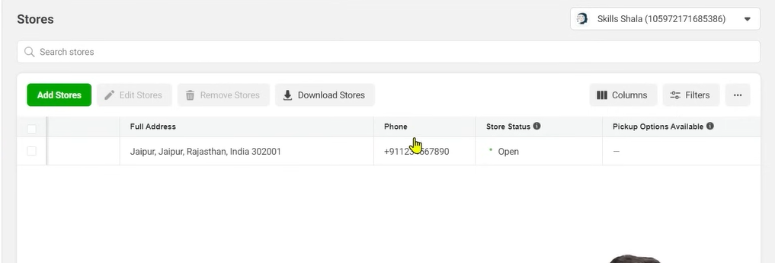

The open in Store Status is open

**Phase 79**

Store id will be unique

We mention local descriptor which is an important thing and it is like a landmark type it will be used as a landmark when the user sees the store ad online

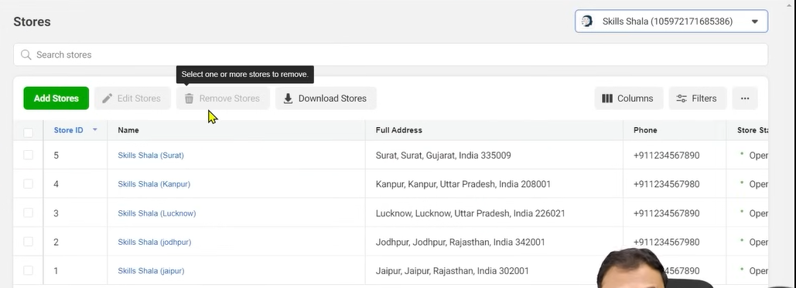

Now you can see the list above of store we created

Now the question is that when we will run our store traffic campaign now whether we want run to run our ad around all the stores or we want to run our add around specific stores for example if we want to run ads around Rajasthan stores in that particular cases we need to make a store set

And after making store set we can run our ad around it.

By using store set we can run our store set campaign

Now create a store set campaign and then we reach ad set level

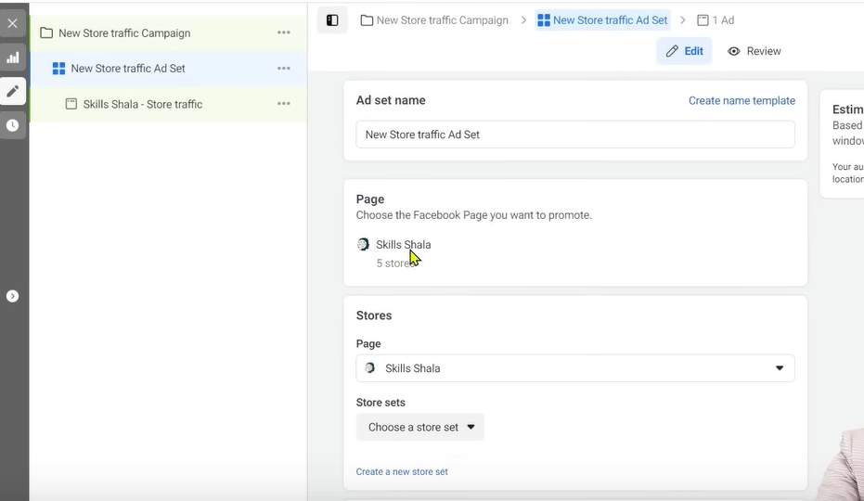

We see our page is selected and 5 stores are connected to this page

This will make all the store selected but if you want to run ads around store set

Then click on choose a store button If you don’t have any then a blank list will be shown

So click on create a store set as shown below the Choose a sore set button

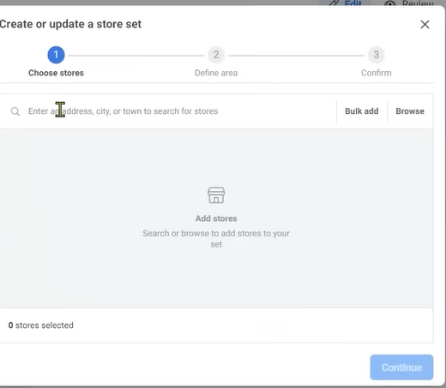

You will see the small window like above

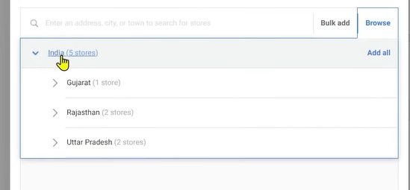

Now go to browser

And then expand store in India

So in India it is written 5 stores

And in Rajasthn we have two store among 5

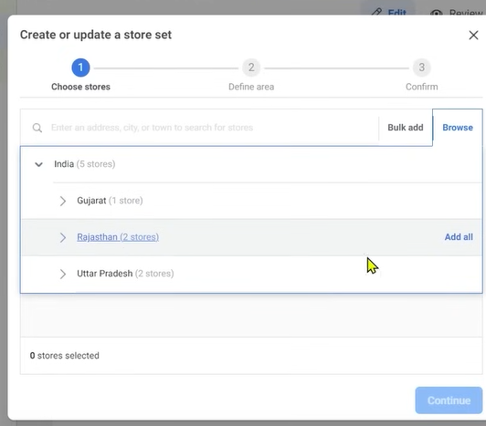

In rajasthan click on add all

Now click on continue

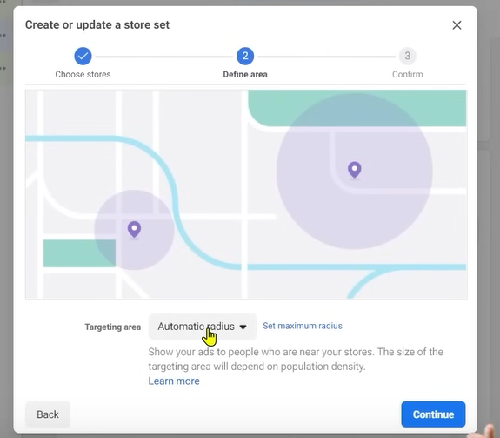

And now you are saying that stores selected in Rajasthan select the area around it

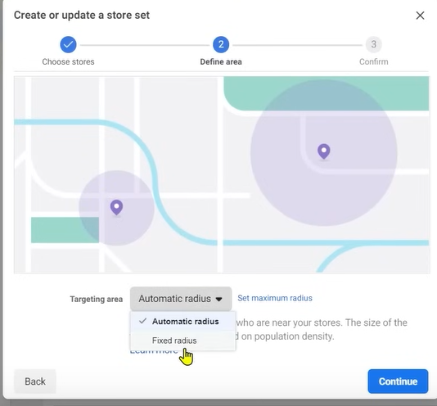

Now whether you choose Automatic radius or Fixed radius

In automatic radius facebook decide what should be the radius by which you can get better performance

In fixed you choose your radius

Now clikc on continue

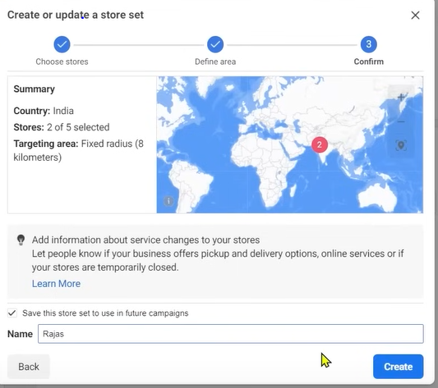

Now in name tell the name of your storeset name it such that it represent its location Now click on Create

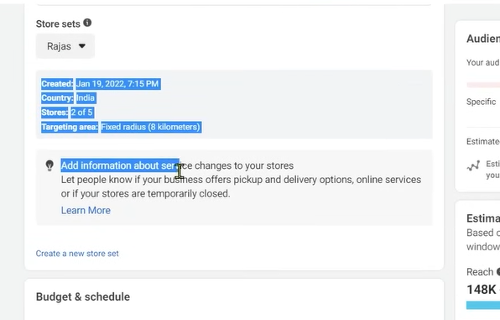

Now abive you can see that storeset is added

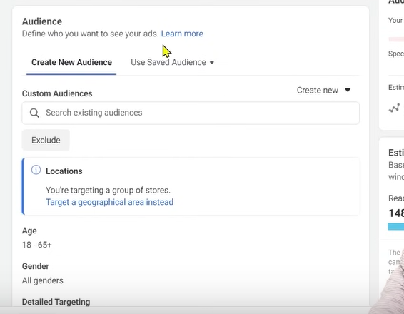

You can see the location option is removed in the audience since we are targeting stores

Now in ad level where our actual ad will be shown

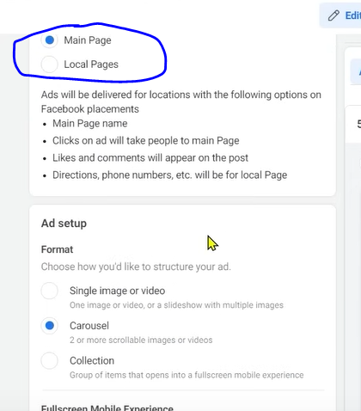

Here from marked above you can tell whether you want to run through main main page or local page

By Local Pages we mean if a Jaipur person is watching the ad then show Jaipur related page

If we go to local page

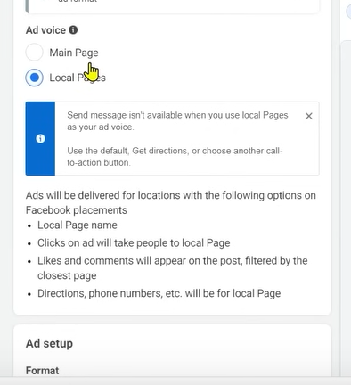

By Jaipur relted page we mean Jaipur related information

With out primary page our store page is also created

When your store pages is created do you ent to run your ad through store pages or main pages

Measn whoever will interact with your ad from any location will see your primary page

Local pages is recommended

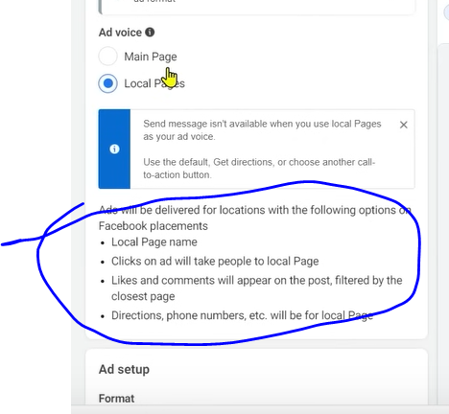

Whatever will be happened is written in marked above

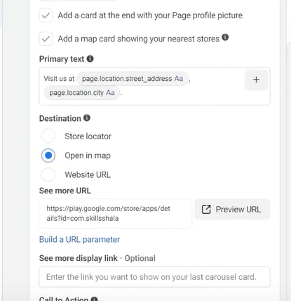

If after choosing image and in destination we click on Open in Map

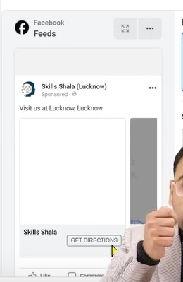

And when you click on Get direction button when he is in Jaipur location then the local page related to Jaipur and the address mentioned there and the store we made for Jaipur its address will be shown in the map.

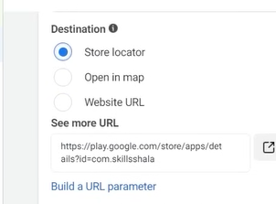

And when someone chose Store Locator when the person is present in jipur and when they click on get direction then they will get the location of the Jaipur store



And the teacher is present in lucknow the preview is showing Lucknow

So your brand is one but because of different store we have different local pages and different addresses an phone numbers So the user will only see the store close to him

This is the benefit of tore location ad

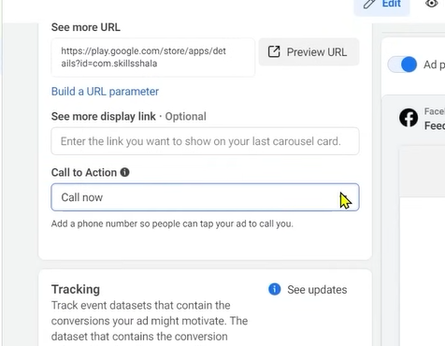

We also have Call to Action button

If we chose instead of get direction and choose Call now button then at what phone number the call will go

If there is a Jaipur guy then he must be seeing it from the Jaipur local page

These type of ad better when you have different stores

If there is a franchise business and if there is a business which is flourished in all over India For them this type of ad can be better

We need to keep a thing in mind we need to understand from the starting whatever type of business we are promoting and for running ads that for any business there is no all campaigns

It will better you understand it early for what type of business we need what type of ads.

If you have only one store an you still use store ads then it will not be helpful

If you have only one store then you will have only single page even if it is a local sop will you still run the store for it the answer is no. if there are multiple store then it is benefitial

Because normally you will bound your radius and then run the ad and set the location and choose direction in call to action then you can bring traffic there you can increase the footfall and can increase your people in your physical location.

If there are multiple store then you will see how better it will perform

Facebook has given you multiple campaign types in keeping mind of multiple type of business

We need to figure out what type of business we are promoting or advertising it.

Lesson 62:-

In this lesson we will learn about **Facebook Ads Domination Strategy**

Lets suppose we have some requirement that we have a business or clients business we are running ads for them under a specific location we assume on city level like in Delhi we are running our ad

**Phase 80**

and there target audience is like that there targeted audience is interested in Sports. Can we do something like in Delhi all the people interested in sports should see the ads

What we are trying to say that we want to dominate our area in sports niche mean all people interested in sports should watch our ad.. IS it possible and yes then how and on the level of execution what are the challenges we face. If we want to execute and implement it practically

Through facebook ad is it possible if yes then what is the right and the challenges we will face.

The primary focus of the lesson is that can we in a specific niche or category can we dominate Can we show our ad to the all people inside that niche and after dominating that niche we see whether it is at location or city wise or statewise, country wise. If we talk about India Level

I assume that we want ot show our ad to all the people like sports all over India then what will be the challenges. This work is not that easy .It si difficult on execution level and more thing come in it especially is budget

When we talk about domination and showing ad in a way that we want to show our ad in whole area who are interested in a topic there budget is an important factor it play a very important role there. So first thing we need to understand that whatever we are going to discuss in this lesson is basically a higher budget strategy means whatever point we will discuss the will only be implements when we have there is no constraint to budgets and budget should not be limited we must be flexible of term of budget . Whatever budget we need should be there

If you are saying that I in a particular area in a particular niche and on the other hand you say you have only limited budget these both things occur at once is slightly difficult

When we talk about expanding an area lets take an example we want to target people in Delhi who are interested in sports Here we need budget and we also say we want ot target people coming 3 km , 4, 5 ,6 km radius in Delhi then I need less budget there

Now when we talk about India it is very easy to assume how much there will be potential in terms of number also if we want to do something or clean sweep all it is possible to a limit we will face problem in technical Implementation but it is not like you will not need budget. You will need a very high budget here you can even need lakh per day if you keep this type of expectation here but is it possible yes it is possible but still we will see it is not possible 100 percent that any number of people interested in sports you will make them all see your ad in country level ,state level it is not that easy